# A QUANTITATIVE ANALYSIS OF CANDIDATES IN THE 2019 LOK SABHA ELECTION

**1 . INTRODUCTION:**

* 1. ***OVER VIEW***

*The Lok Sabha is composed of representatives of people chosen by direct election on the basis of universal adult suffrage. The constitution of India allows for a maximum of 550 members in the house, with 530 members representing the states and 20 representing the union territories. The 17 Lok Sabha was formed by the members elected in 2019 Indian general election. Election, all across India, were conducted in seven phases from 11 April 2019 to 19 may 2019 by the election commission of India****.***

* 1. **PURPOSE**
* *The nominations for all phases of the general election have been submitted. We examine highlights from data an candidates who are participating in the ongoing elections. There are 8,039 candidates contesting for 542 parliamentary constituency seats.*
* *On average, 14.8 candidates are contesting per constituency across the country. Among all the states, Telungana has the highest average number of candidates contesting. This is primarily due to 185 contestants from Nizamabad. Excluding Nizamabad, the state’s average number of contestants would be 16.1.*

**2 . PROBLEM DEFINITION & DESINGN THINKING :**

**2.1 EMPATHY MAP**

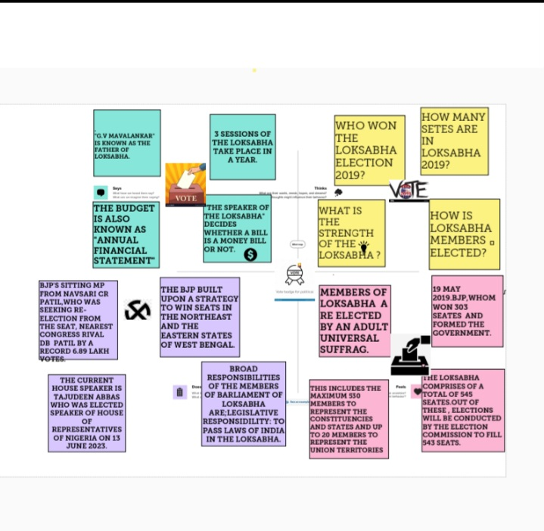

**2.2 IDEATION & BRAINSTORMING MAB**

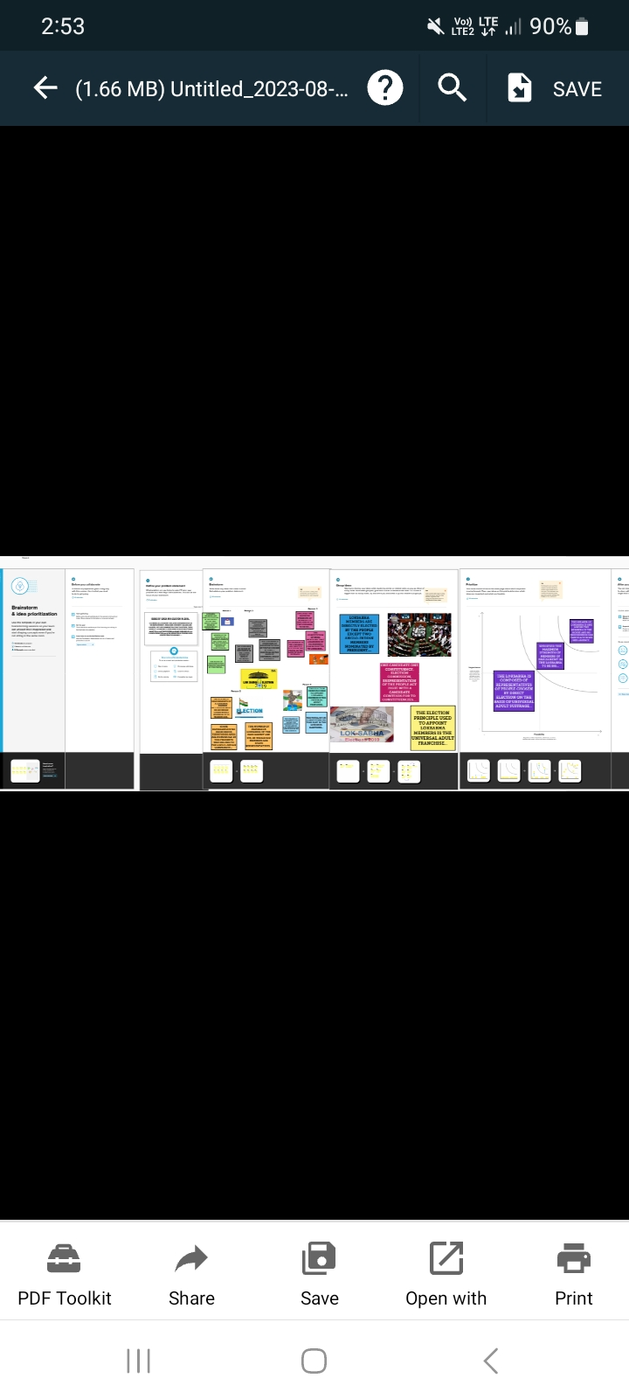

**3. RESULT :**

**3.1 DASHBOARD**

*A dashboard is a graphical user interface (GUI) that displays information and data in an organized, easy-to- read format. Dashboards are often used to provide real-time monitoring and analysis of data, and are typically designed for a specific purpose or use case. Dashboards can be used in variety of settings, such as business, finance, manufacturing, healthcare, and many other industries, They can be used to track key performance indicators (KPIs), monitor performance metrics, and display data in the form of charts, graphs, and table***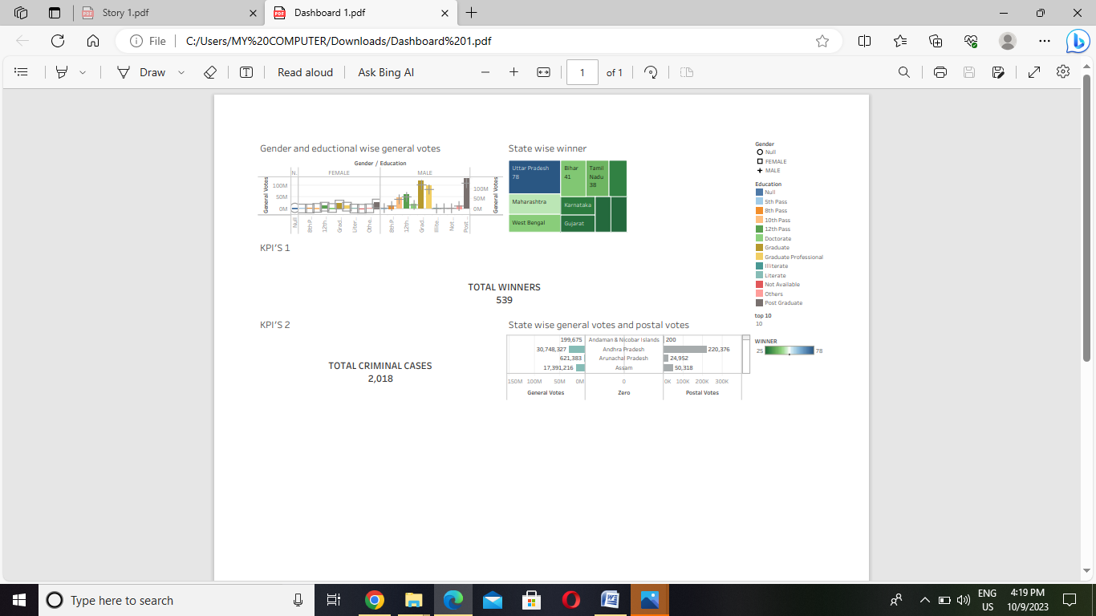**

* 1. **STORY**

*A data story is a way of presenting data and analysis in a narrative format, with the goal of making the information more engaging and easier to understand. A data story typically includes a clear introduction that sets the stage and explains the context for the data, a body presents the data and analysis in a logical and systematic way, and a conclusion that summarizes the key findings and highlights their implications. Data stories can be told using a variety of mediums, such as reports, presentations, interactive visualizations, and videos*

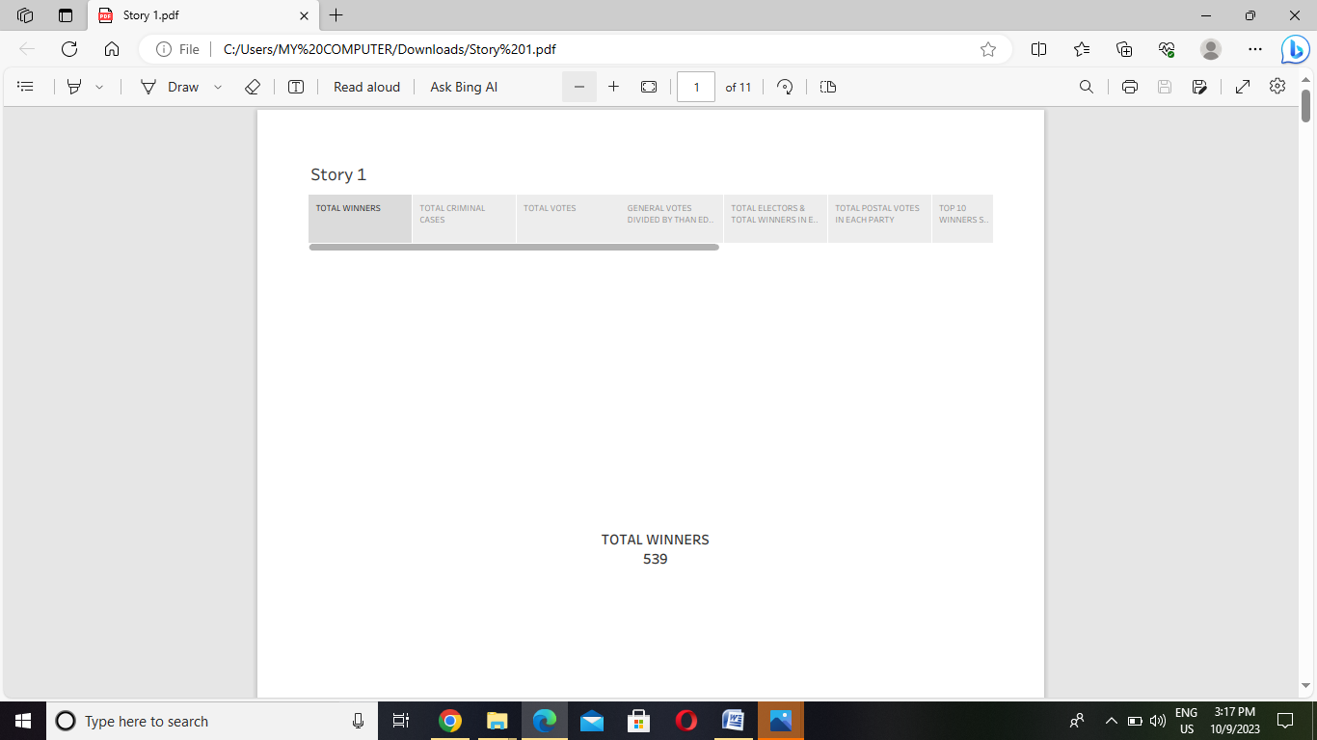

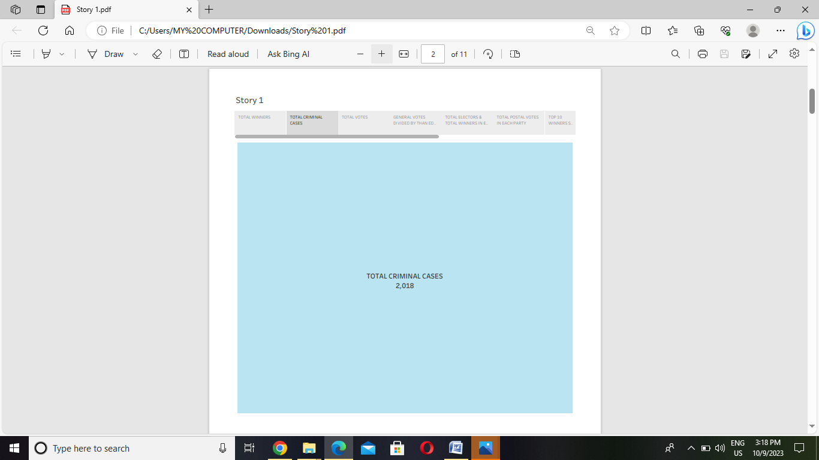

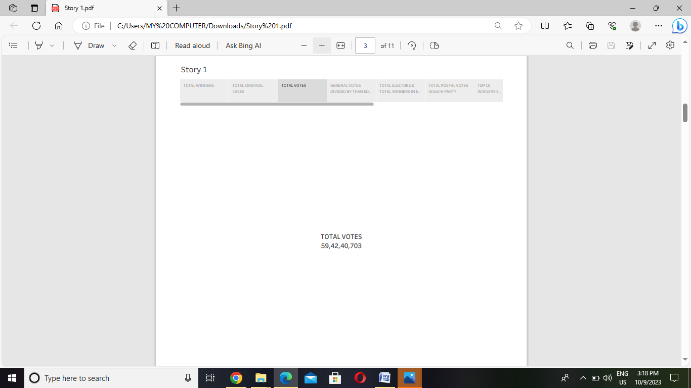

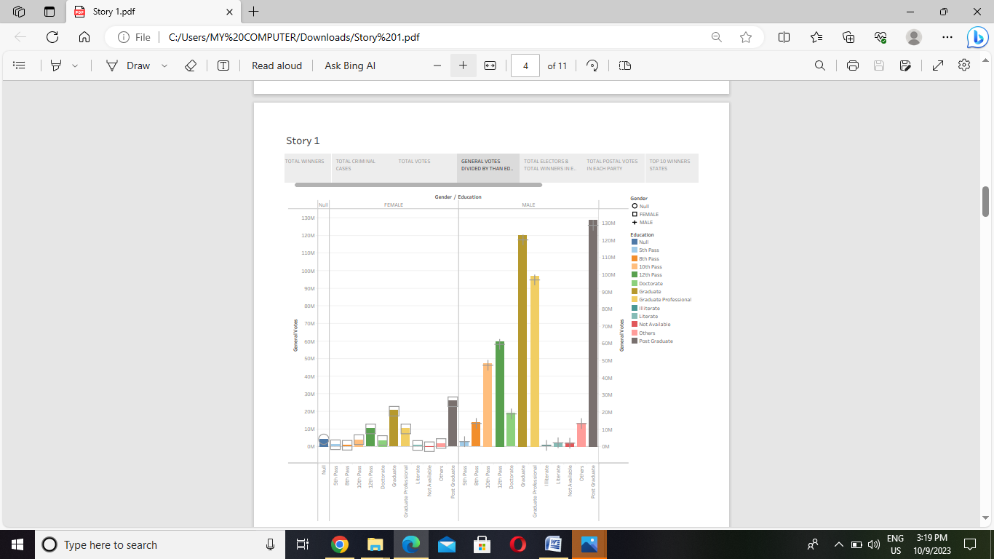

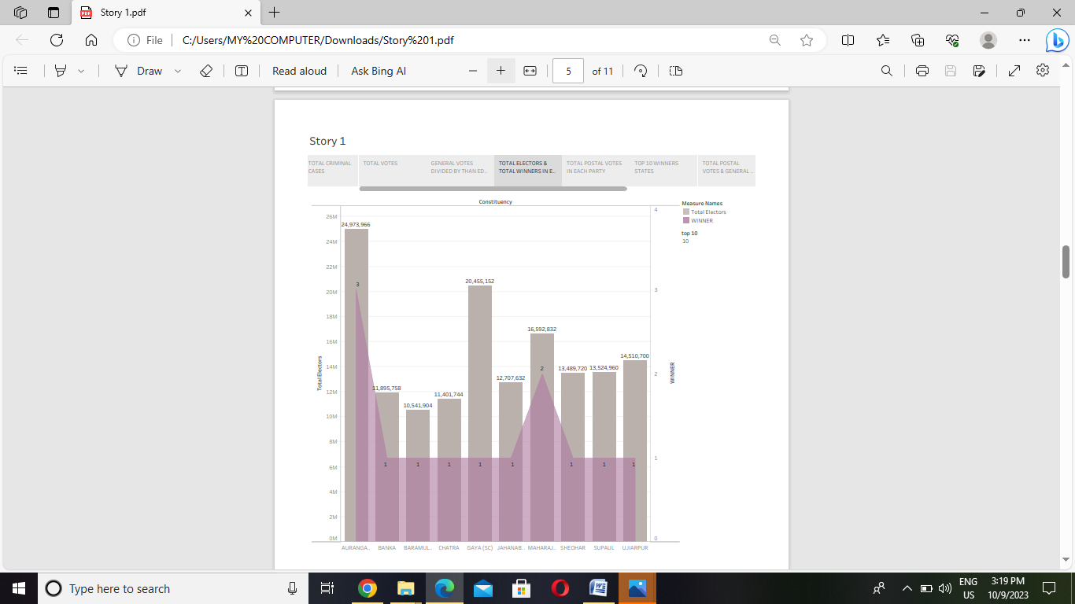

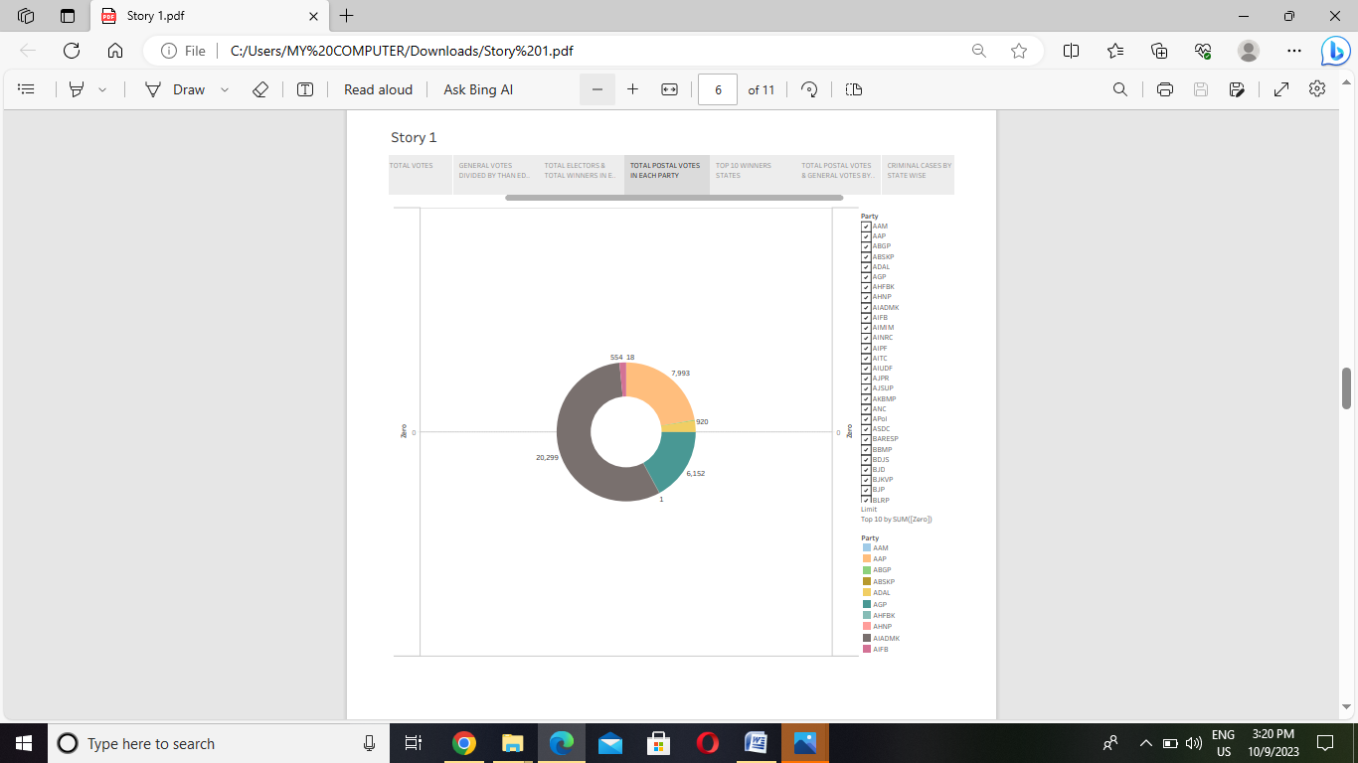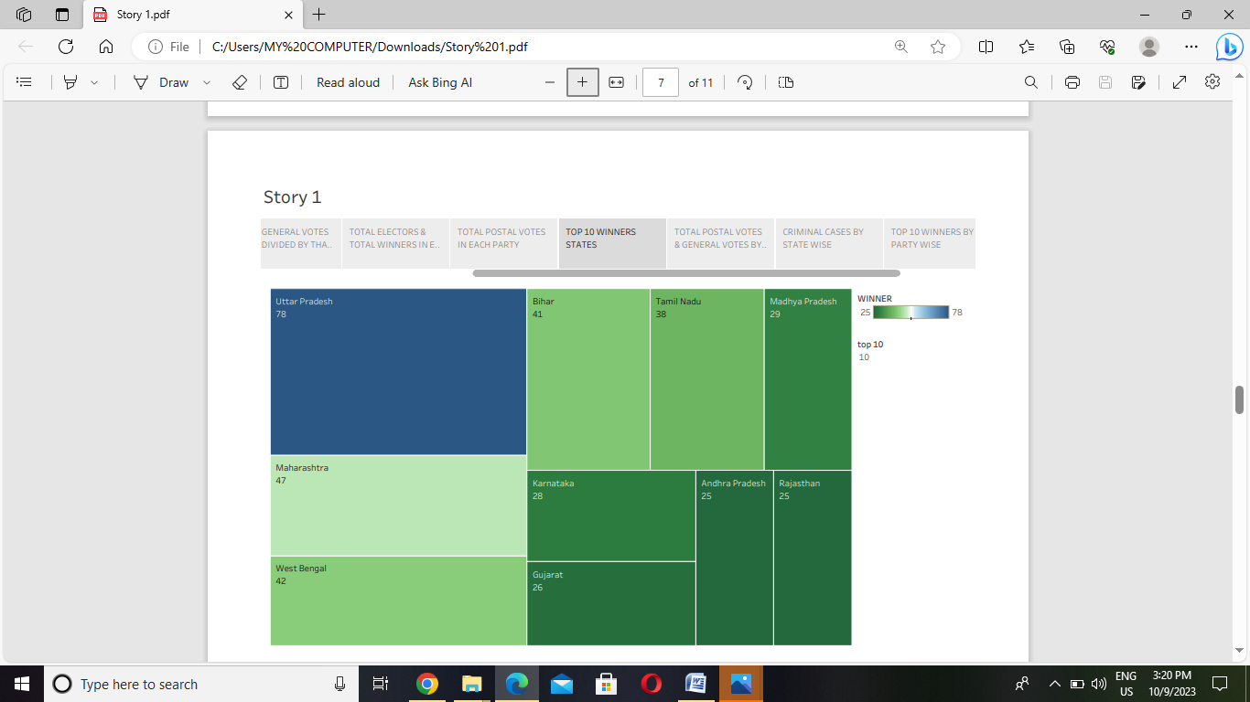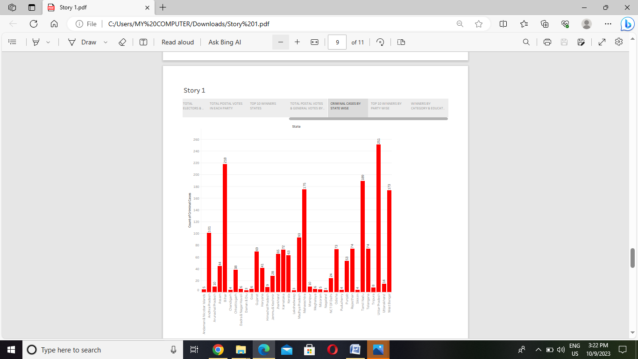

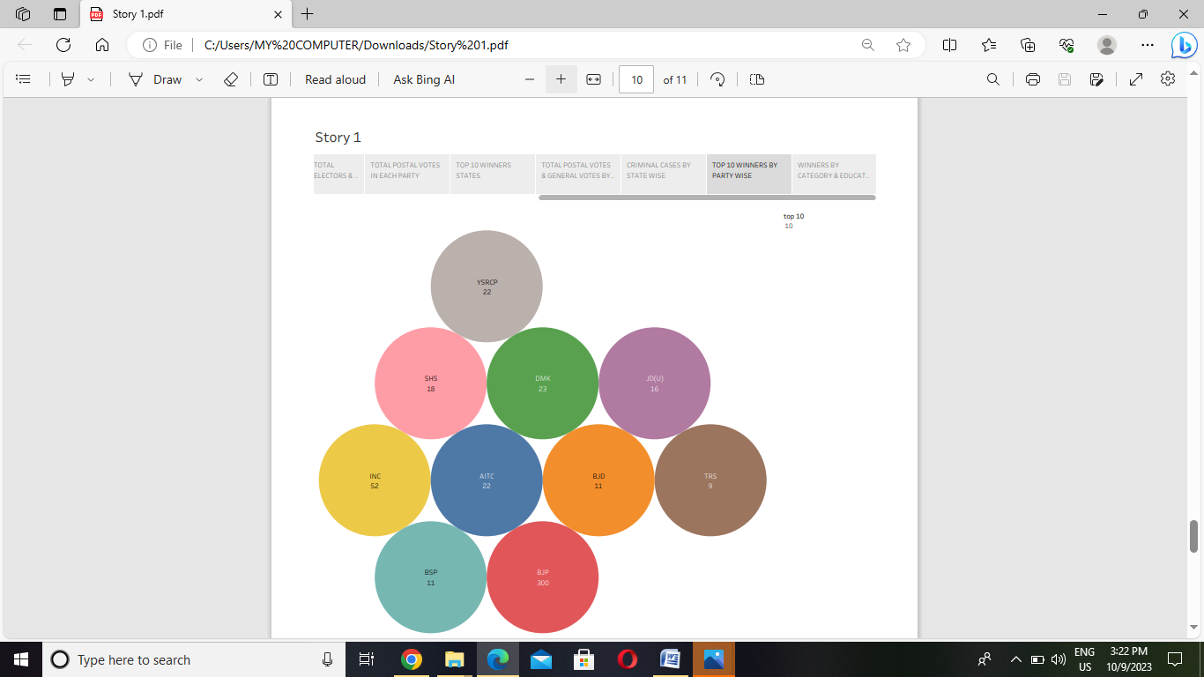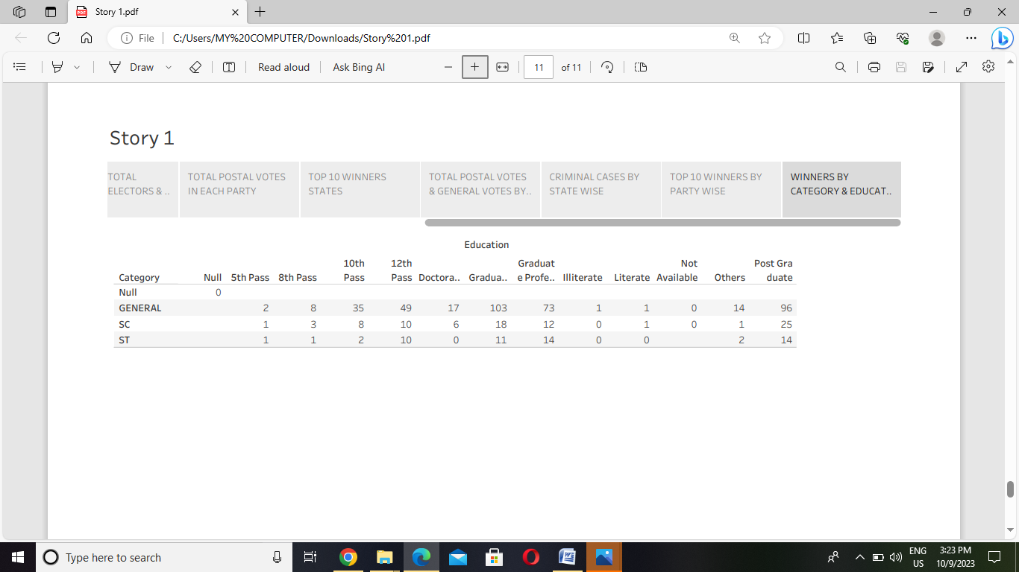

**4 . ADVANDAGES :**

* **Elections are the people directly to the Lok Sabha and each state is divided into territorial constituencies under two provisions of the constitution: Each state is allotted several seats in the Lok Sabha in such a manner that the ratio between that number and its population was as close to uniform as possible.**
* **Elections to the Lok Sabha (and also to vidhan sabhas) are carried out using a first-past-the-post electoral system. The country is split up into separate geographical areas\known as constituencies, and the electors can cast one vote each for a candidate, the winner being the candidate who gets the most votes.**

**5. DISADVANDAGES:**

***The congress party campaign highlighted “agrarian distress” as an election issue. The BJP campaign highlighted that the congress party had been in power of five generations of the Nehru dynasty and its past promises and campaign issues have been empty.***

**6. APPLICATION:**

* ***The stability of the government, whether in the form of a majority or a coalition, plays a crucial role in instilling confidence among investors. Moreover, the historical trends highlight the importance of policy continuity and economic reforms in driving market performance.***
* ***While elections introduce volatility, the focus should be on the government’s ability to provide stability and implement effective measures for sustainable economic growth. Ultimately, informed investment decisions should consider the broader economic landscape and reforms rather than being solely influenced by election outcomes.***

***7. CONCLUSION:***

* ***Elections are by the people directly to the lok sabha and each state is divided into territorial constituencies undertow provisions of the constitution: Each state is allotted several seats in the lok sabha in such a manner that the ratio between that number and its population was as close to uniform as possible.***
* ***Elections to the lok sabha (and also to vidhan sabhas) are carried out using a first-past-the-post electoral system. The country is split up into separate geographical areas/ Knows as constituencies, and the electors can cast one vote each for a candidate, the winner being the candidate who gets the most votes.***

**8.FUTURESCOPE:**

* ***The government’s focus on fiscal discipline and economic stability further restored investor confidence, leading to a positive trend in the stock market and increased foreign direct investment inflow.***
* ***The government’s focus on structural reforms, sector liberalization, and attracting foreign investment revitalized the economy, resulting in increased GDP growth, controlled inflation, and favourable market performance.***
* ***However, within the next two years, it fell around 50% due to domestic and global factors such as the 9/11 attack. As a result, at the end of the NDA government tenure, the annual compound return was just 3%.***